INITIALIZE SPARK SESSION

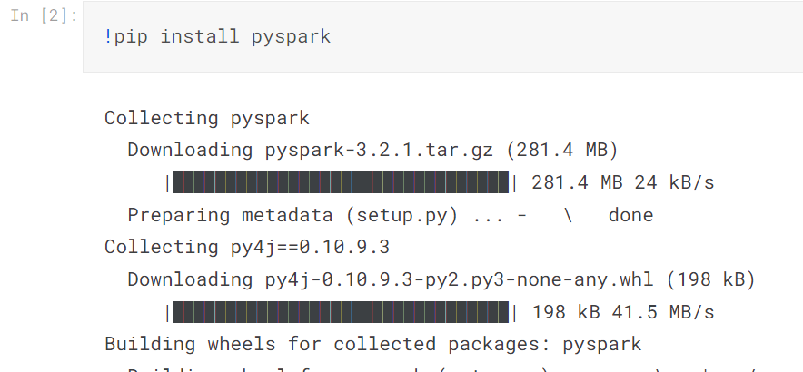

LOAD NECESSARY LIBRARIES

LOAD DATASET IN APACHE SPARK

SELECT DATA FOR RECOMMENDATION

 CONVERT STRINGS customer_id AND article_id COLUMN TO INDEX FORM

CREATE TEST AND TRAIN DATASETS

ALS MODEL

RMSE

GENERATE PREDICTIONS

RECOMMEDATIONS BY article_id

RECOMMENDATIONS BY customer_id

CONVERT BACK TO STRING FORM

RECOMMENDATIONS BY customer_id

IMPORT to_read DATA

CREATE TEMPORARY TABLE

IMPORT RATINGS DATA AND CREATE TEMPORARY TABLE

IMPORT BOOKS DATA AND CREATE TEMPORARY TABLE

CONVERTING BOOKS DATA INTO PANDAS DATAFRAME

BOOKS WITH MOST NUMBER OF RATINGS ON GOODBOOKS

BOOKS WITH HIGHEST AVERAGE RATINGS ON GOODBOOKS